Lesson 6- playing with polymers

Experiment introduction and method | Picture | For you to fill in
Experiment 1- Nappies  Find out how much water you can pour into the nappy before it stops absorbing.  Method  Pour 50cm³ portions of water into the nappy until it stops absorbing. Start pouring them quite quickly then slow down as the nappy gets fuller. | 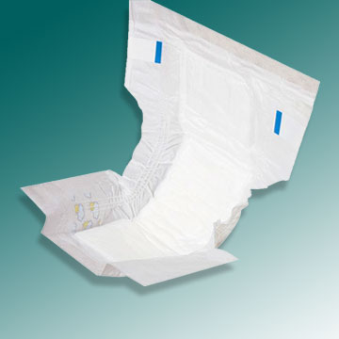 | Tally of how many measuring cylinders’ worth of water was poured in  The nappy absorbed _____ cm³ water
Experiment 2- what’s in a nappy?  The powder you’ve got is the stuff that’s in the nappy. How do you think it works?  Method  Place a spatula of nappy polymer into the beaker. Add 20cm³ water. Wait 2 minutes, and watch what happens to the polymer, then add more water. | 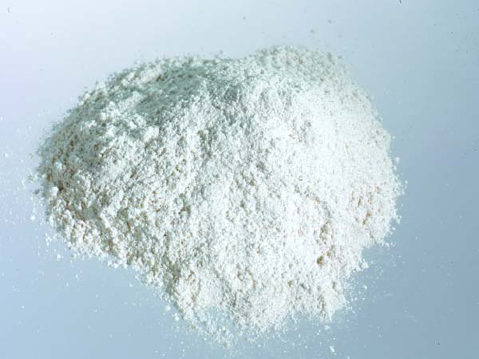 | I think the nappy polymer works by…
Experiment 3- polymer bouncy ball  We can change the properties of PVA glue by adding Borax.  Method  Place a spoonful of PVA into the jar and add a few drops of food dye. Stir. Add some Borax solution and stir again. Massage into a ball. | 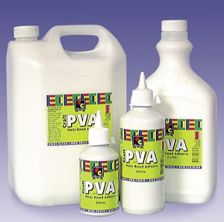 | The properties of PVA glue are…  The properties of the new polymer are…

