What rubbish did we throw away?

Make a tally chart of each item that you and your family threw away. Go for the material that most of the item was made of.

 | Plastic | Paper/card | Glass | Food waste | Other
My totals
The class totals

Complete this bar chart to show what rubbish the class threw away. Choose a sensible scale for the y-axis.
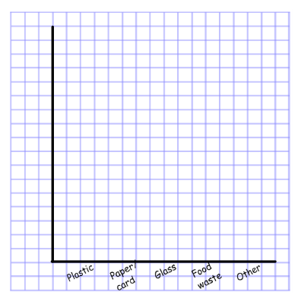

Now answer the questions:
- The type of rubbish me and my family threw away most was ________________________________________________
- The type of rubbish me and my class threw away most was ________________________________________________
- My thoughts on the problems with throwing away this type of rubbish are ______________________________________________________ __________________________________________________________________________________________________________________

